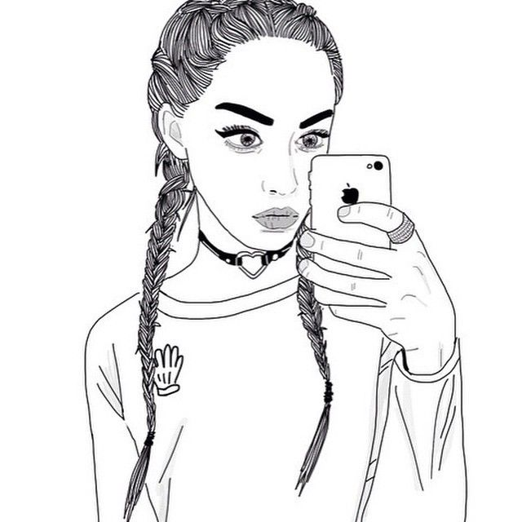

I Contain Multitudes:
The Importance of Self-Identity & Intersectionality

Key Concepts
- Self-Identity – it may seem obvious but for the sake of clarity, your self-identity is a combination of personality traits, abilities, physical attributes, interests, hobbies, and/or social roles from your personal identity that you specifically selected to identify yourself.
- Intersectionality – The interconnected nature of social categorizations such as race, class, and gender as they apply to a given individual or group, regarded as creating overlapping and interdependent systems of discrimination, disadvantage, or in some cases privilege.
- White Privilege – Inherent advantages possessed by a white person on the basis of their race in a society characterized by racial inequality and injustice.

“Afro-Latina” Discussion questions

- What lines in the first part of the poem indicate that the poet (speaker in the poem) had issues with her identity?

- What would you say are some of the poet’s multiple identities? What are some of yours?

- In what places does the poem turn? In other words, where does the move from expressing one set of ideas or emotions to another?

- In one line of the poem the poet states: “How quickly we forget where we come from…” Why is it important to remember where you came from?” How does that impact your self-identity?

- There is a line in the poem where the poet describes her people as a “beautifully tragic mixture / a sancocho of erased history. Do you feel like the history of your people is adequately taught in history books? Why would someone want to erase your history?
Writing Prompts: Take 15 minutes to write about one or more of the following prompts.

- Write about one of your most significant memories in which you felt disadvantaged or privileged based on some aspect of your identity.

- Write about a turning point in your life when you went from being ashamed about some aspect of your identity to feeling a sense of pride or self-acceptance.

- Think about your multiple identities. Make a list of 10 “I Am…” statements regarding those identities and expand on some aspect of that identity. For example, if you are a Black woman, don’t just say “I am a Black woman,” try to offer other details such as, “I am a Black woman and no, you can’t touch my hair.”
Note: You can take these prompts in different directions. They could be written as a poem, a journal entry or even a micro-essay.

Afro-Latina
by Elizabeth Acevedo

Camina conmigo.
Salsa swagger anywhere she go
Como '¡la negra tiene tumbao!
¡Azúcar!'
Dance to the rhythm
Beat the drums of my skin
Afro-descendant, the rhythms within
The first language I spoke was Spanish
Learned from lullabies whispered in my ear
My parents’ tongue was a gift, which I quickly forgot
Realizing my peers did not understand it
They did not understand me
So I rejected habichuela y mangú
much preferring Happy Meals and Big Macs
Straightening my hair in imitation of Barbie
I was embarrassed by my grandmother’s colorful skirts
Eh-broken inglish when she spoke
I would poke fun at her myself
hoping to lessen the humiliation
Proud to call myself American
Citizen of this nation
Hated caramel-colored skin
Cursed God I’d been born the color of cinnamon
How quickly we forget where we come from
So remind me
Remind me that I come from the Taínos of the río
The Aztec, the Mayan, Los Incas
Los Españoles con sus fincas buscando oro, and the Yoruba Africanos que con sus manos
Built a mundo nunca imaginado
I know I come from stolen gold, from cocoa, sugarcane
The children of slaves and slave masters.
A beautifully tragic mixture
A sancocho of erased history
And my memory can't seem to escape
The thought of lost lives and indigenous rape
Of bittersweet bitterness
Of feeling innate
The soul of a people, past, present and fate

Our stories cannot be checked into boxes.
They are in the forgotten, undocumented, passed-down spoonfuls of arroz con dulce
At abuela's knee
To the way our hips skip to the beat of cumbia, merengue y salsa.
There in the bending and blending of backbones we are deformed and reformed beings
It's in the sway of our song,
The landscapes of our skirts,
The azúcar beneath our tongues
We are the unforeseen children
We're not a cultural wedlock
Hair too kinky for Spain too wavy for dreadlocks
So the palms tell the cuentos of many tierras
Read our lifeline
Birth of intertwined moonbeams and starshine
We are every ocean crossed
North Star navigates our waters
Our bodies have been bridges
We are the sons and daughters
El destino de mi gente,
Black
Brown
Beautiful.
Viviremos para siempre
Afro-Latinos hasta la muerte

https://youtu.be/tPx8cSGW4k8

