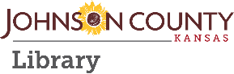
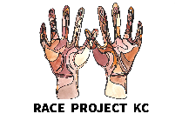
Welcome!
to the
Race Project KC Health Equity Workshop

We have reached the middle of our Race Project KC event schedule and up next is the Health Equity workshop. Previously we explored our identities and what makes us who we are. Next, we examined how artists of color are changing representation in culture, media and art. Now we will be combining identity and representation with an examination of health equity and the challenges that are faced by many people in this country.

Inside the Health workshop box, you will find snacks and resources that you can use for both your mental and physical health such as, a water bottle, snacks and self-care exercises that can be utilized for mental pick me ups. Also included is the booklet Kansas City Black History that has been graciously donated by Glenn North and the Bruce R. Watkins Cultural Center in Kansas City, MO.

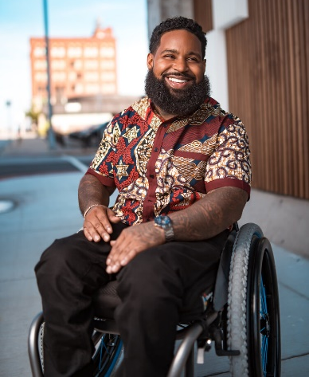
During this Health workshop we will have a presentation given by representatives from Children’s Mercy Hospital. They will help us to understand how our zip codes play a part in healthcare. Glenn North will be joining us again to lead us throughout our workshop, he will also be guiding us in a writing prompt towards the end of the day.

Additionally, we will have special guest, Wesley Hamilton. He is the founder of the organization Disabled But Not Really and he was featured on season 4 of the reality TV show Queer Eye. Wesley will be telling us his story and how being differently abled has helped him go from victim to victory.
There is a small amount of prep work that we are asking you to think about before we all meet:
Photo credit: 8won6 photography

- Clipped to the back of this welcome letter is an M&M Anger game and a small bag of M&M’s that we will be using during the breakout sessions. Think about how you deal with situations that make you angry. Are there decisions that you have regretted making during times of anger? How do you calm down afterwards? Keep these things in mind to share in your breakout room.

- Included in your box is a writing prompt with the Race Project KC logo. This will be used towards the end of the workshop. Think about the question that we have asked and how it relates to you and your school, your neighborhood, your family etc.

- Watch the video Land of Opportunity presented by PBS and directed by Nico Wiggins. You can find it by searching Land of Opportunity Kansas City on YouTube. You will be shown a small clip during the Children’s Mercy presentation, but we are asking that you to watch the complete video beforehand.

If you are joining the workshop from school, please bring the items you gathered from home with you. Come ready to be inspired, to share, to listen and learn from each other. Also, have fun and prepare to take what you learn into the wider community.

We’ll see you at your designated time and date, with Zoom information to be provided soon.

