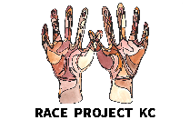
Welcome!
to the
Race Project KC Representation Workshop

We can’t wait to kick off 2021 with our second Race Project KC event, the Representation workshop with the Nelson-Atkins. We’ll be digging deeper into our identities and exploring how our stories, and those of others, are represented in culture, media, and art.

If you’re reading this, you’ve got in your hands a box of items for you to use during the event. You’ll find some refreshments, mementos, and a few art-making supplies to get you started. We have included some custom-made buttons that provide a sneak peak of art that we will be discussing. Our art-making will be all about your histories and stories, so we encourage you to spend some time gathering additional materials that have personal meaning to you from around your home.

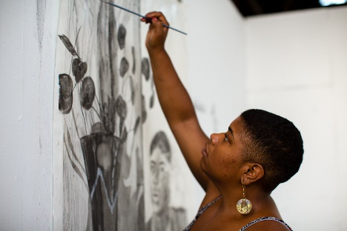
Artist Glyneisha Johnson will lead us in an art-making process to make, in her words, “vaults of lineage” using collage to reflect on and explore our own identity, culture, and personal narratives in a way that promotes a sense of mending and healing through visual imagery.

Before your workshop, take a little time to search for the following items to use in the art-making process:
Photograph by Molly Stinchfield, courtesy of Art OMI
- Find a vault: Be intentional about choosing a vault that lends itself to your story, i.e. small recycled drawer, music or jewelry box, window box, recycled frame, lantern. This object should not be larger than 16” on any side.
  - This is the most important thing to locate prior to the workshop. If needed, a shoe box, a cereal box, or even the box your supplies came in could work!
- Gather “spirit filled things”: These are small and thin items around your home that symbolize your identity and culture. Ask permission if needed to dedicate precious items to this work (i.e. shells, fabric items, figurines, small candles, plant matter, healing stones, rocks)
  - We encourage you to find at least three physical objects to use in your collage. You can choose to make these items removable from your final piece, so that they are not permanently damaged or altered.
- Gather paper ephemera that is special: Old book pages, photographs or photo copies, handwritten letters, stamps, tickets, postcards, napkins, brochures, papers you kept for memories, phrases significant to you or your family.
  - You can choose to make family photos, etc. removable from your final piece, so that they are not permanently damaged or altered.
- Collect other collage materials: Magazines, newspaper, cardboard, and additional paper material that will be in service to your objects of significance.
  - We have provided some paper and magazine pages, but encourage you to seek other colors, patterns, and graphics that hold significance to you.

If you are joining the workshop from school, please bring the items you gathered from home with you. Come ready to be inspired, to share, to listen and learn from each other. Also, have fun and prepare to take what you learn into the wider community.

